**An adopted approach to food waste and insecurity at the University of Florida**

## **Table of Contents**

**Abstract**

**Introduction**

**Methodology**

**Results**

**Discussion**

**References**

## **Abstract**

Our society faces a paradox. In 2020, 690 million people faced food insecurity[5], yet roughly one-third of all edible food produced is lost or wasted every year [6]. This inefficiency is due to the interaction of many elements and activities in the food supply chain [7]. Yet with such a large problem, finding a starting point can be challenging. Students at Universities are one avenue available to start solving these global problems. The research done provides an answer to the question surrounding donating food waste to students in need through the use of abundant technology. Programs have proved to be successful in the past, and current data indicates there remains a demand for initiatives like these.

## **Introduction**

Food is essential for a living being. Organisms of all types depend on it to live and continue breeding new life. However, in a developed society, where food production is automated and abundant, problems arise. Data shows that one-third of all edible food produced is lost or wasted, yet, there are still people today that experience food insecurities [1]. This misallocation of resources raises questions about the efficiencies of the current system of food production and presents opportunities to create a better system. The objective of this research is to explore methods of allocating the existing resources in a more effective manner, such that less food is wasted, and more humans are fed sufficiently. This will be explored by questioning whether donating excess food results in less food waste and less food insecurity.

Excessive food waste is an international problem. Yet, under the U.S. Department of Commerce and U.S. Department of Energy’s new grant awarded to the University of Florida, a solution that would benefit the university is the best way to receive funding for the proposal. Therefore, the extent of this work is focused on the University of Florida and its partners. Further, solving a global problem is highly improbable if it is not solved at a local level first [2]. This work will determine whether the hypothesis is effective enough to solve the problem on a global scale. For clarity, the research question is as follows: Does the distribution of excess food at the University of Florida lessen the problems surrounding food waste, from a disposal perspective, a hunger perspective, or both?

## **Methodology**

The scope of this work is limited to the University of Florida. This allows for a more directed solution, with fewer possibilities for noise in the data, unreasonable outliers, and geographical-related differences. A set of specific, food-waste-related questions were developed over a day and ordered to ensure ideal response flow. Raw bulk data was collected through a Qualtrics survey, conducted over five days, distributed through social media including Facebook, GroupMe, Instagram, and others; as well as by word of mouth. A professor of water and soil sciences - a sponsor for the universities’ composting club - and the sustainability coordinator for the university dining halls were also contacted with thoughts on the project and our questions.

The questions presented in the survey dealt with food insecurity issues among students their food waste volume, perception of the University of Florida food waste volume, and their willingness to attempt to reduce the magnitude of the problems surrounding food waste by using a text message system to be notified if there is excess food at a University of Florida dining hall, that would otherwise go bad and be wasted.

During the data collection period, efforts were made to maximize the response rate of the survey to omit sparse data problems and find correlations. Each day the survey was live, it was reposted to social media, to ensure a fresh set of eyes landed upon it. The request for comment from the professor was never returned. The request for comment from the sustainability coordinator was not returned either.

## **Results**

Following five days of intensive survey promotion, it had accumulated seventy-six responses. Since the question posed considers two different perspectives - hunger and waste - the results of the survey presented valuable data for both. An optimization made to the data consisted of removing all responses completed by people who are not students of the University of Florida.

It was noted that 5% of respondents currently experience food insecurity and 22% know someone who has experienced food insecurity. Additionally, 41% percent of all respondents were not aware of resources at the University of Florida for students with food insecurities. While the data does not represent a majority of respondents, it is not an insignificant percentage. Furthermore, the potential impact on these respondents would open opportunities to reduce wasted resources, given that an unutilized resource is a wasted resource.

The data collected on food waste was entirely based on the perception of the students, which can make a difference in campus culture and influence students. Students were asked about their personal food waste volumes and their perception of the university food waste volumes. The proportions of this data can be seen in the graphs below.

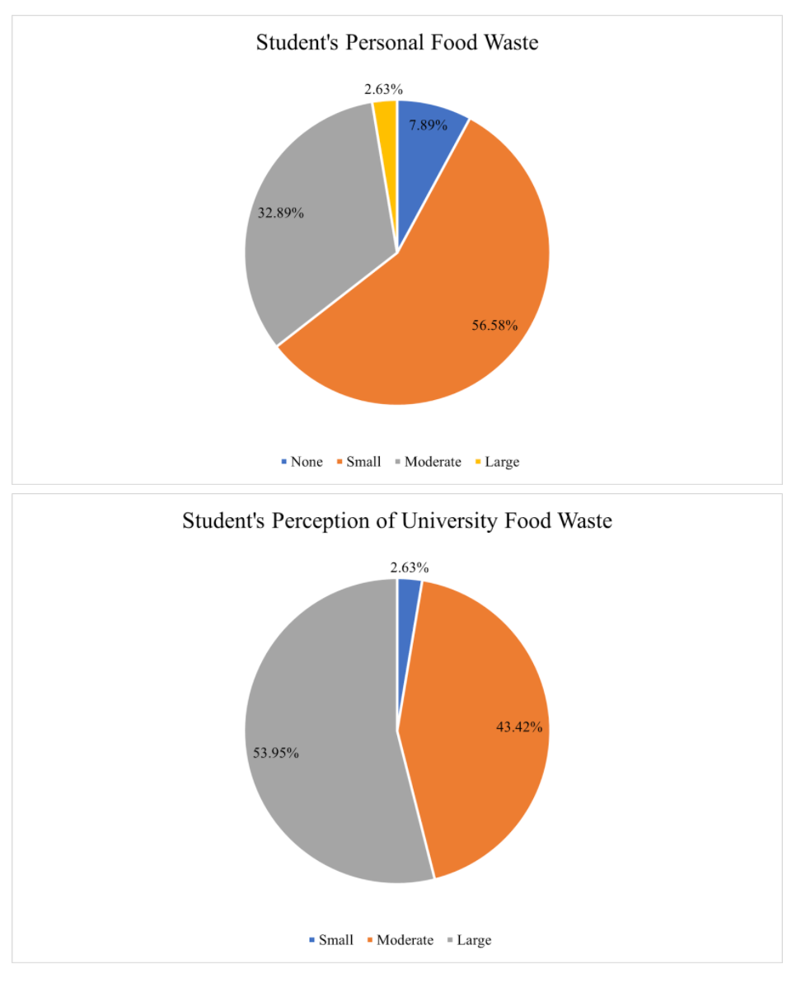

5-day survey data from UF students on the volume of food waste emitted by themselves and their perception of the food waste produced by the University of Florida. Graphed using Qualtrics Survey Technology.

Combining the proportion of respondents with food insecurity with the proportion of respondents who believe the University of Florida produces high amounts of food waste, the respondents were asked if they would be willing to sign up for the excess food notification system. Of those experiencing food insecurity, 75% confirmed they would sign up. Of those who are aware of someone else experiencing food insecurity 71% of them would sign up. Finally, of those with no issues or awareness of food insecurity, 60% indicated they were likely to sign up. Overall, two-thirds of respondents confirmed they were likely to sign up for the notification system, which would allow them to obtain food that would end up being wasted.

## **Discussion**

Provided with this data, it indicates that students with food insecurities do not account for the majority of those likely to use the proposed service. This seems to have been known by Colorado State University, which developed an initiative called the ‘Ram Food Recovery Program’, that sends text alerts to students and employees for excess food from catered events[3]. The effectiveness of this program proved to be sufficient when - after the COVID-induced pandemic and worldwide shut down - the University decided to relaunch the program for the 3rd year, not including the year of the pandemic [4].

While initiatives elsewhere proved to be successful, strong limitations were apparent in the data collected. The sample size does not represent the population, encompassing only 0.1% of the student base of the University. Additionally, the survey was only open for five days; two of which were the weekend, a time traditionally spent away from school-related tasks and work. Further, this study was conducted during the summer, a time when the majority of students are not on campus and could be working full time to provide for themselves and their families, unable to spend time on social media filling out surveys pertaining to research without immediate benefit to their situation.

For a full-scale study, a survey like this should be conducted in person, likely through campus during midday and mealtimes, around dining halls and food pantries. The results of this research indicate that there are students experiencing food insecurity, which considering the data is sparse, the true proportion must be much higher. However, there is hope in the future, highlighted by other initiatives, including Colorado State University Ram Food Recovery Program.

## **References**

[1] J. Gustavsson, C. Cederberg, and U. Sonesson, “Extent, Causes and Prevention,” *Global Food Losses and Food Waste*, 2011.

[2] S. L. Hirsch, “Making global problems local: Understanding large-scale environmental issues using ethnographic methods,” Science, Technology, &amp; Human Values, vol. 45, no. 5, pp. 963–973, 2020.

[3] Colorado State University, “Rams against hunger,” *Lory Student Center*, 27-Jul-2021. [Online]. Available: https://lsc.colostate.edu/slice/slice-engagement/rams-against-hunger/#1551371741738-06e362ba-7507. [Accessed: 28-Jul-2021].

[4] C. S. U. L. Staff, “Rams food recovery program has relaunch,” *CSU Life*, 07-Feb-2021. [Online]. Available: https://csulife.source.colostate.edu/rams-food-recovery-program-has-relaunch/. [Accessed: 28-Jul-2021].

[5] Food and Agriculture Organization of the United Nations, *The state of food security and nutrition in the world 2020: transforming food systems for affordable healthy diets*. Rome, Italy: FAO, 2020.

[6] J. Gustavsson, C. Cederberg, and U. Sonesson, “Extent, Causes and Prevention,” *Global Food Losses and Food Waste*, 2011.

[7] K. L. Thyberg and D. J. Tonjes, “Drivers of food waste and their implications for sustainable policy development,” *Resources, Conservation and Recycling*, vol. 106, pp. 110–123, 2016.